Syllabus resources for faculty
Updated August 2026

Sample language faculty might consider for use in their syllabi is listed below. Language related to the credit hour policy is required for all syllabi. It is best practice to include language about support services and campus resources.

Basic Course and Policy information
Course name, number, section number, term and year, course location
Course description
Faculty name and contact information, office hours, office location and other communications policy
List of all required texts and materials
Learning objectives for the course, how these relate to college-wide learning outcomes (see sample syllabus language)
Grading Policy & Grading Scale
Clear and detailed attendance policy that is consistent with the Attendance Policy approved by faculty in May 2024 should be stated in the syllabus (see Excessive absences under Registration, Enrollment & Attendance in the College Catalog). Additional guidance regarding implementation of the Attendance Policy can be found here.
Due dates for all assignments, including reading assignments and projects
Course schedule (account for holidays and Symposium Days)
Credit hour policy (required) Augustana’s credit hour policy must be stated clearly in each syllabus. Policy language and syllabus template language for various kinds of courses (4-credit, 2-credit, Independent Study, etc.) are available on this page of the Augustana catalog.

Student Services and Resources Available to Augustana Students

Disability & Access Resources at Augustana:
Augustana College is dedicated to fostering a learning environment that supports the diverse needs of all students. If you discover any barriers to your learning in this course, please feel free to discuss your concerns with me.
If you have a disability or believe you may have one, Disability & Access Resources (DARS) can help make sure you have the support you need. If you have any questions or concerns about getting support for your disability, you can email disabilityservices@augustana.edu.
If you have already been approved for accommodations at Augustana College through Disability & Access Resources, please share your Accommodation letter with me as soon as possible, and let’s discuss how I can help support your learning needs.

Basic needs:
Any student who has difficulty affording groceries or accessing enough food is encouraged to visit the Campus Cupboard, located in the Brunner basement-inside the mailbox room-open Monday through Thursday from 3-5 pm. If you lack a safe and stable place to live and believe this may impact your performance in the course, please contact the Director of Residential Life for support (residentiallife@augustana.edu).

Honor Code and academic integrity
All students are required to adhere to the principles of academic integrity outlined in Augustana College’s Honor Code. Every member of the Augustana community has the obligation to report violations of the Honor Code to the Honor Council. The Honor Code provides detailed definitions of infractions, the Honor Pledge, information about the composition of the Honor Council, and access to reporting forms.

Title IX
Augustana College is committed to creating a campus community that is free from bias, discrimination, and harassment. If you have encountered any form of discrimination on the basis of sex, including sexual harassment, sexual assault, stalking, dating violence or domestic violence, you are encouraged to report it through the Title IX Office.

As a faculty member, I am required to report to the Title IX Coordinator/Deputy Coordinators any information I receive about possible sex discrimination. This includes information shared in class assignments, discussions, emails, and/or shared conversations outside of class. If the Title IX Coordinator/Deputy Coordinators receive a disclosure, they will reach out to you with resources and options. You are not required to respond to this outreach.

If you wish to speak with a Confidential Resource (not required to report to the Title IX Coordinator or Deputy Coordinators), Please contact:
- Counseling Services 309-794-7357
- Campus Chaplain, Office of Campus Ministries, 309-794-7213
- The College has arranged for the availability of a confidential advocate employed by Family Resources to provide support to survivors of sexual assault. Our Campus Advocate, Pauline, holds office hours every Thursday in Sorensen Hall Rm 254 from 9:00am-4:00pm or other days by appointment. Pauline can be reached at paulineg@famres.org or by phone at the Family Resources 24/7 Hotline: 309-797-1777 (an on-call advocate will respond if Pauline is not available)
Pregnancy and/or Pregnancy-Related Conditions
If you are pregnant or experiencing a pregnancy-related condition (including termination) the Dean of Students Office has services to support to you. Contact Farrah Roberts (farrahroberts@augustana.edu), Assistant Dean, Director of Student Well-Being and Resiliency. She can help you to understand your rights/options, provide academic accommodations, and/or other supportive measures.

Your right to education free from discrimination and harassment
Augustana College is committed to fostering a safe, inclusive environment free from all forms of discrimination and harassment. Our Policy Against Discrimination and Harassment describes your right to freedom from discrimination and harassment on the basis of race, color, religion, national origin, service in uniformed service, veteran status, sex, age, political ideas, marital or family status, pregnancy, disability, genetic information, gender identity, gender expression, sexual orientation, or any other classification protected by law. College employees should report suspected violations, even if the individual who was or is the victim has not filed a complaint.

Health and wellness
Your health and well-being are important. Free counseling and mental health services are available through the Augustana Student Counseling Services. To schedule an appointment, please email cherimizaur@augustana.edu.

Augustana Convenient Care Clinic powered by Genesis is located on campus in Baldur House (behind the Gerber Center).

Students can access free 24/7 clinical counseling, medical services, and crisis counseling through TimelyCare. Learn about this resource under “Free tele-health care thorough TimelyCare”.

Limited psychiatric services are also available through TimelyCare. To inquire about psychiatric care, please reach out to Augustana Student Counseling Services.

If you ever are experiencing a mental health crisis, including feeling as though you cannot keep yourself physically or emotionally safe, call (309)740-7507 to access CrisisNow services. CrisisNow is free immediate 24/7 crisis counseling services with a licensed clinical therapist. CrisisNow is part of TimelyCare’s suite of clinical services.

Augustana also offers independent mental health and self-care courses through TAO that are self-paced and proven to increase life satisfaction.

Technology requirements and support
*If your course requires the use of technology for student engagement, please include this information in your syllabus.
To fully participate in this course, you will need access to a device that meets the following requirements (list requirements, e.g., with a webcam and microphone and reliable internet). You will also need to be able to use Moodle, Google Meets, (and any other specific platforms needed for this course). You can download the Open LMS app for accessing Moodle by visiting this link: https://ethinkeducation.com/products/mobile/ (when launching the app, enter “moodle.augustana.edu” in the “your Moodle site” field).
If you need help with technology, contact the ITS Help Desk at helpdesk@augustana.edu or 309-794-7293.

Religious holiday policy
Augustana College celebrates the importance of religious expression in the lives of our students and “offers every student the opportunity to develop a life-shaping spirituality." (See also The Five Faith Commitments of Augustana College). Consistent with our commitment to creating an academic community that welcomes and respects religious diversity, we commit ourselves to making every reasonable effort to support students in observing major religious holidays without academic or co-curricular penalty. The Office of Campus Ministries maintains a Religious Observance Calendar on its website, which includes religious observances in major religious traditions.

Students are required to notify their instructor in advance if they must miss class in order to observe a religious holiday and must make prior arrangements with the instructor to complete work missed during their absence. Final exams or other exam week requirements that may overlap with a religious holiday must be petitioned using the Exam Week Policies standards adopted by the faculty.

While the college encourages students to celebrate any cultural customs and traditions that hold personal significance, we are not able to excuse students from class attendance or participation in course requirements for cultural observations. Questions that arise in carrying out this policy should be addressed to the College Registrar or the Office of Academic Affairs.

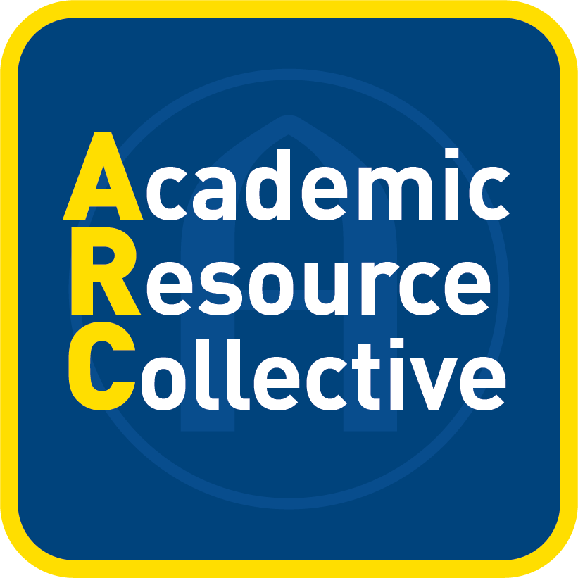

The Academic Resource Collective (ARC) is Augustana’s hub for academic support. Through ARC, students will find academic accommodations support, academic coaching, English Language Learner support, group drop-in tutoring, individual tutoring, reading and writing support, and support for student success strategies and study skills.
Scan the QR code to learn how ARC can be your partner in navigating success.


Supports Offered Through The Academic Resource Collective

Peer Academic Coaching: The Academic Resource Collective offers free academic coaching to all Augustana students. Trained Peer Academic Coaches help students achieve their learning goals by facilitating workshops and through individualized support. Coaches cover a variety of topics, such as time management, overcoming procrastination, exam preparation, test anxiety, note-taking, reading strategies, study strategies, and more. Students can find more information about Academic Coaching by visiting the Academic Resource Collective webpage, and they can sign up for one-on-one appointments via Starfish.

Faculty should tailor text related to tutoring to the resources available for the course.

Peer Subject Tutoring: The Academic Resource Collective (ARC) offers free peer tutoring to help students succeed in their courses. Trained peer tutors ask guiding questions to encourage deeper thinking about course concepts, discuss exam preparation strategies, and break down complex problems. Rather than giving out answers, tutors act as guides and coaches so that students can master the skills on their own.

If Drop-in and Appointment tutoring is available for the course:

Drop-in and Appointment Tutoring are available for this course. Drop-in tutoring is available [INSERT DAYS AND TIMES In LOCATION—see Drop-in Hours section of this document for additional information]. You can come and go as you like, receive individual attention when needed, and work independently or in groups, with a tutor nearby to answer questions.

Appointment tutoring is ideal if you are seeking one-on-one support from a peer tutor with experience in this course. To make an appointment, visit the Tutoring website.

[If Facilitated Study Groups, Drop-In, and Appointment tutoring are available for this course:]
Facilitated Study Group sessions, Drop-in, and Appointment Tutoring are available for this course. Facilitated Study Group sessions will meet [INSERT days, times, and weeks they are meeting (see information from the STEM/Q section).].

Drop-in tutoring is available [INSERT days, times, and weeks for Drop-in tutoring (see the STEM|Q section of this document for information)]. You can come and go as you like, receive individual attention when needed, and work independently or in groups, with a tutor nearby to answer questions.

Appointment tutoring is ideal if you are seeking one-on-one support from a peer tutor with experience in this course. To make an appointment, visit the Tutoring webpage.

If Appointment tutoring is available for the course:

Appointment Tutoring that provides one-on-one support from a peer tutor with experience in this course is available. To make an appointment, visit the Tutoring webpage.

For lower-level courses in which there is no prearranged appointment tutoring, you could include language such as: Tutoring for this course is arranged on an as needed basis. To make an appointment, visit the Tutoring webpage. Tutoring will be provided if a tutor can be identified.

Contact karenlindebrekke@augustana.edu or stop by Olin 320 or the STEM|Q Center (Hanson 202) for more information.

Reading/Writing Center
The Reading/Writing Center (RWC), located in Gerber 423, provides feedback for any student, on any reading/writing assignment, in any class. Staffed by 26 peer tutors and two faculty tutors, the RWC is a free service. Students are encouraged to come early and often, scheduling in-person appointments and/or requesting feedback via email as they wish. We also take walk-ins as our schedule allows.

In-person appointments with peer or faculty tutors are 40 minutes long and are ideal for brainstorming and early-stage drafting, reading-related sessions, or just having a friendly conversation about all things reading/writing.

Feedback via email is a good option for those who aren’t available during RWC open hours or who would prefer to communicate via writing rather than face-to-face.

Make an appointment for either type of session via Starfish (instructions). If you have any trouble doing so, email readingwritingcenter@augustana.edu or call 309-794-8987 during open hours: 10 a.m.-4 p.m. Monday-Thursday; 10 a.m.-3 p.m. Friday; and 7-9 p.m. Sunday.

STEM|Q Center
The STEM|Q Center, located in Hanson 202, provides support for students enrolled in STEM and other courses requiring quantitative reasoning skills. In the STEM|Q Center, students are welcome to join facilitated study groups or drop-in tutoring sessions (facilitated by faculty or trained peer tutors), meet with peer subject tutors for one-on-one tutoring appointments, participate in workshops or other events, use the workstation, study with peers or individually, or seek advice from faculty or staff. The
Center is staffed by 30–40 trained peer tutors, 10–12 faculty members, and 1 staff member. All services are free: students are simply required to sign-in/sign-out when they visit the Center.

STEM|Q Center Hours
Week 1 and Finals Week: 9:00AM–5:00PM Monday–Thursday; 9:00AM–4:00PM Friday
Week 2–14: 7:00PM–9:00PM Sunday, 9:00AM–9:00PM Monday–Thursday, 9:00AM–4:00PM Friday.

STEM|Q Drop-In Tutoring Schedule
Drop-in tutoring sessions are provided by faculty and trained peer subject tutors Weeks 2–14, starting the Sunday of Week 2 and ending Friday of Week 14. No appointments are necessary to participate in drop-in sessions. Visit the STEM|Q webpage to see the drop-in schedule.

Peer Drop-In Tutoring Sessions
For Biology, General and Organic Chemistry, Physics, Mathematics, Engineering, and Computer Science:
Sunday, Tuesday, and Thursday, 7:00PM–9:00PM

For Accounting, Business, Economics, Psychology, Sociology, and Anthropology:
Monday and Wednesday, 7:00PM–9:00PM (Both days Week 2–7; at least one day Week 8–14)

Drop-In tutoring will not be in session during holidays and breaks. The Center will be open 9:00AM–5:00PM Monday–Thursday; 9:00AM–4:00PM Friday when the college is open but there are no classes. Sunday Peer Drop-in Tutoring will not be held if the following Monday is a holiday.

Faculty Drop-In Tutoring Sessions
Several faculty members hold drop-in tutoring hours for (e.g., for biology, chemistry, and physics) in the STEM|Q Center throughout the week. Students can find the schedule for faculty drop-in tutoring times by visiting the STEM|Q Center webpage or by visiting the STEM|Q Center (Hanson 202) for more information.

[In addition to faculty including their office hours/drop-in tutoring times on their syllabi, we recommend they also note that students may meet with any faculty supporting drop-in tutoring for the course.]

Facilitated Study Groups
Facilitated study group sessions are available for select courses. These groups are facilitated by trained, experienced tutors (supplementary instructors) who work closely with faculty teaching the courses to provide additional practice and productive study sessions. Supplemental materials are provided to students for them to develop and check their conceptual understanding and problem-solving skills.

In fall 2026, facilitated study group sessions are provided for the following courses:
CHEM 131, MATH 090, MATH 140, MATH 160, and MATH 260.
[The schedule for the facilitated study sessions for these courses is TBD.]
Students do not need to register for the facilitated study groups, and they can join at any time, though we encourage students to attend regularly and for full sessions. Faculty teaching these courses work with STEM|Q Center staff and the supplementary instructors to schedule the sessions, to ensure that appropriate supplementary materials are provided, and to encourage students to participate in the sessions.

Equipment Available for Check-Out for In-Center Use
Laptops and calculators* (TI-84 CE Plus, TI-30, and 4-function). Students ID will be held during check out timeframe.
*Calculators may be available for short-term check-out (same-day return) for use on campus.

General Hours for the STEM|Q Center
Week 1 and Finals Week: 9:00AM–5:00PM Monday–Thursday; 9:00AM–4:00PM Friday
Week 2–14: 7:00PM–9:00PM Sunday, 9:00AM–9:00PM Monday–Thursday, 9:00AM–4:00PM Friday.
In general, the STEM|Q Center will not be open when the college is officially closed (holidays and breaks). The Center will be open 9:00AM–5:00PM Monday–Thursday; 9:00AM–4:00PM Friday when the college is open but there are no classes. Unless otherwise noted, Sunday Peer Drop-in Tutoring will not be held if the following Monday is a holiday or the college is on break.

