Student Planning in Arches – An Overview from Course Planning to Registration

- An advisee reviews their Progress Report in Arches, searches for courses that satisfy graduation requirements and uses the “Add Course to Plan” button to add the course to their plan for the upcoming academic year. For more information on student steps, click here. This is an example of a student’s Course Plan in the “Timeline” tab:

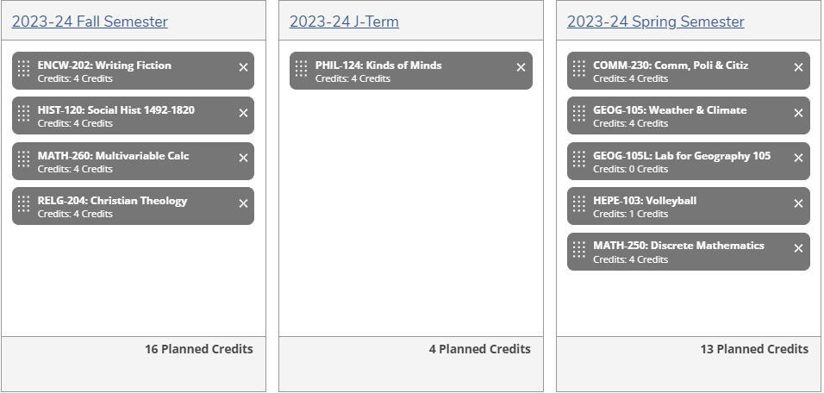

- When the student is ready for their advisor to review the plan, they click on the “Advising” tab. They “Compose a Note” explaining the rationale for their plan and click on “Save Note” and then “Request Review” by their advisor.

- The advisor is notified in three ways that an advisee has requested a review of their Course Plan:

  - An automated email is sent to the advisor requesting the review.
  - Upon login, a notification appears in the upper right corner:

  - When the advisor accesses their advisee list, this student’s record will appear at the top of the advisee list with a check mark under the “Review Requested” column:

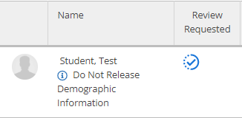

- The advisor clicks on “View Details” for that student:

- The advisor clicks on the “Notes” tab first to view the student’s note explaining their rationale for the courses in their Course Plan:

- The advisor clicks on the “Timeline” tab to review the student’s plan:

An example of a student’s Course Plan for the 2023-24 academic year:

- Both student and advisor should refer to the Progress Report (formerly the Program Evaluation) to check that planned courses meet the appropriate graduation requirements for the planning period.

- Both student and advisor can see planned courses on the Progress Report. However, Learning Perspective, suffix, and PE courses will not show up on the Progress Report until the student is registered for the course(s). If a student does not register for a planned course, it may be easily overlooked on the Progress Report when planning future semesters.

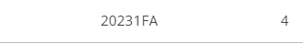

- Additional tips for reviewing a Course Plan:

- Has the student included major/minor courses that must be taken next year to stay on track for graduation?
- Has the student placed major/minor courses in the term in which they are offered?
- Is the student eligible to take the major/minor courses in the plan?
- Are liberal arts core requirements included in the plan?
- Has the student planned for at least 12 credits for fall and spring?
- Has the student planned for credits less than or equal to 34 (or more depending upon major) for the year?
- Has the student included upper division courses as appropriate?

- The advisor can now take the following steps.

- Click on the “Notes” tab and “Compose a Note,” providing feedback on the student’s Course Plan. Provide clear, specific feedback on changes or concerns. Students and advisors can view all notes in Arches under “View Note History.” Creating and saving your notes in Arches provides documentation of your recommendations that may be helpful if your advisee deviates from the plan for any reason.

- Click on the “Review Complete” button. When clicked, the advisor will be asked if they would like to archive this course plan. An archived course plan provides a record of the agreed-upon coursework for the following semester/year and is especially helpful if the student deviates from the plan.

- Important: “Review Complete” does not approve the Course Plan. It means only that the advisor has reviewed the plan and provided feedback.

“Review Complete” does not clear the advisor restriction on course registration.

- Whenever an advisor clicks on “Review Complete” or adds a note in Arches, the
student is notified by email.

- If the student makes changes to their plan, they can request another review by the advisor using the same steps outlined above.

- As registration approaches for the upcoming semester, students will begin to plan for specific sections of the courses they’ve planned under the “Schedule” tab.

- An advisor restriction on class registration will be placed as usual. Advisors must use the “Advising Complete” button to lift the advisor restriction for the upcoming registration period.

- When a student’s registration window opens, the student registers for courses for the upcoming semester.

- Advisor can see the student’s registered courses under the “Course Plan” tab in the “List” or “Calendar” view.:
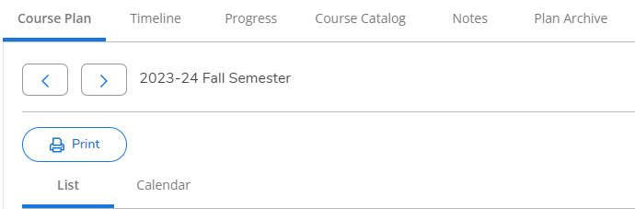

For more information and helpful videos for advisors, click here. To see the student’s view and process, click here. Questions? Email marywindeknecht@augustana.edu, call x8290, or send Mary a chat.

Continue reading for more information on the differences between “Advising Complete” and “Review Complete.”

How does “Review Complete” differ from “Advisement Complete”?

Button | Function | Timeframe | Specificity | Frequency
Review  Complete | Confirms review of timeline by advisor; does not necessarily mean approval; should include advisor feedback on Course Plan | One full year in advance (currently) | Course codes and numbers only | Can be requested again if student makes changes to plan
Advisement Complete | Clears advisor restriction on registration for the upcoming semester | Upcoming semester only | Course codes, numbers and specific sections | Once within each registration cycle

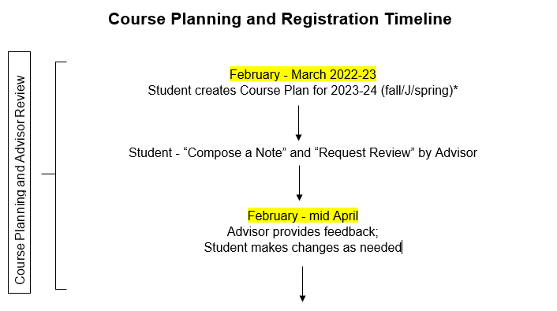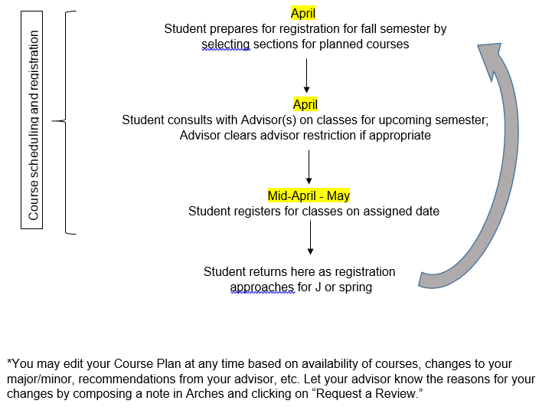
1/23 MW

