HPBX Training Manual for the Yealink T54W Desk Phone
Please keep this guide as a quick reference tool and as a place to jot down important information!
Phone Number and Extension:
VM PIN (6 digits, non-sequential and non-repeating):
CommPortal Password (8-24 characters, at least one capital and lowercase letter, number & symbol):
Admin / End User (circle one):
These are the online account management sites aka the CommPortal (which we will discuss and reference in the training). You will only need two of the CommPortal Links (Based on Location) below. If you are having trouble accessing the CommPortal sites, let us know and we will help you with logging in. The last two sites are for our additional free, online resources, which we encourage everyone to use as a self-service option.
https://vm.mymetronet.net/surround.html#login.html (End User/General VM/TOD/AA)
https://vm.mymetronet.net/bg/surround.html#bg/login.html (Admin User)
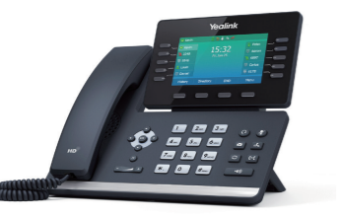
https://d2504j8oxdxpmc.cloudfront.net/pdfs/Support/HPBX-User-Guide-End-User-CommPortal.pdf (CommPortal All User Guide)
https://business.metronetinc.com/business-voice/metronet-business-phone-technologies/ (Online Training Material and Tutorials from Metronet)
Section I: A Brief Introduction to Your Phone and Basic Functions
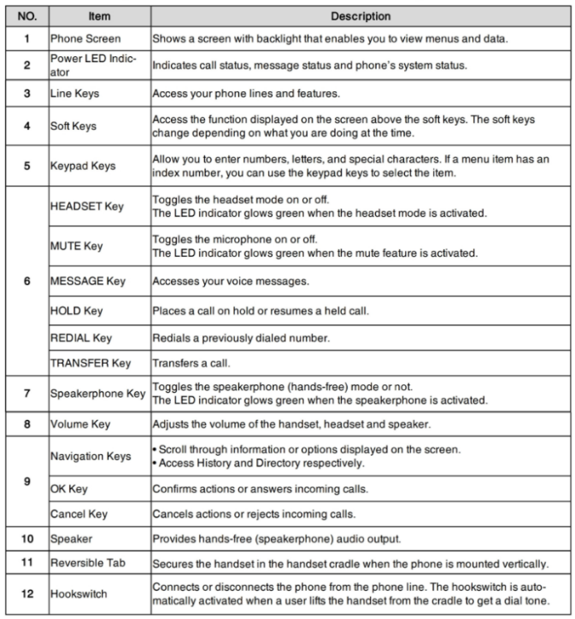
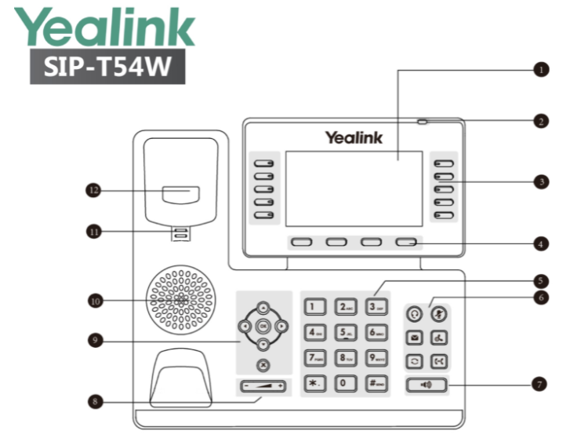

Welcome to the HPBX (Hosted Private Branch Exchange System) Phone system and your new Yealink T54W Desk Phone. The Yealink T54W has a variety of features that will help you manage your new phone system with ease. Pictured above is the basic layout of the phone. There are ten physical “line keys” found on either side of the LCD screen and the four “soft keys” under it. These keys can be programmed with different functions such as:
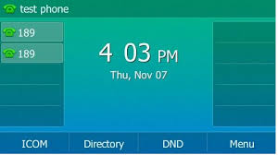
Line Keys
The Line Keys appear on the phone’s Idle Screen (pictured here) and be customized.
- Enhanced Monitor Extensions
- Enhanced Call Parking
- General Voicemail
- Transfers
- Speed Dials/Star Codes
- (It is important to note Line Keys 1 and 2 are USUALLY pre-configured for you to have 2 appearances of your OWN NUMBER. Overwriting them can cause malfunctions where you might not receive calls at all or make it more complicated for you to have more than one call at a time. You can verify this on the Customer CommPortal by going to LINE KEYS and clicking on Key 1 and Key 2. If you see “Line 1” in the boxes, it is set up for 2 appearances and should NOT be changed without first checking with a system administrator or Metronet.)
- The Yealink T54W has a total of 27 programmable Line keys (including Keys 1 and 2). If there are more keys programmed than the available spots, the last key will show “More”, allowing you to see the next set of key options.
Soft Keys
Also seen on the Idle Screen, are the four
default keys. They can also be customized.
- History
- Directory
- DND (Do Not Disturb)
- Menu
- (It is important to note, these key labels listed are just a few examples of what you might see on the Idle screen. Not every phone configuration will show the same default keys, and other keys can be managed in the CommPortal. The Soft Keys will also change and display different functions based on how you are using the phone at that time, as seen in the picture.)
LCD Screens (Idle and Main Menu)
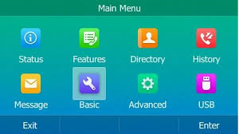
In addition to the Idle screen (above), which shows the line and soft keys, time and date and the status bar, the T54W’s second screen or Main Menu, shows all the shortcut options you can scroll through. Press the Menu soft key on the Idle Screen to see this.
- Status (network and software information)
- Features (call waiting, DND, call forwarding)
- Directory (your BG and personal contacts)
- History (call history)
- Message (voicemail access from the menu)
- Basic (general preferences)
- Advanced (n/a, requires Yealink pw)
- USB (headset, sidecar, call recording)
- (It is important to note, that not EVERY phone configuration is always going to look the same as the illustration. Some features may have been disabled by Metronet, your system administrator or may not be available in your market.)
The Status Bar
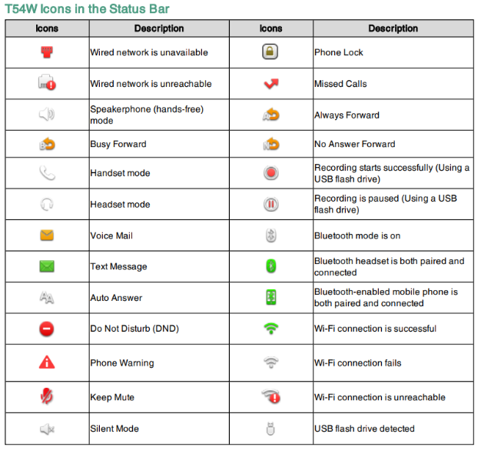
At the top of the phone is a thin bar which will show different icons that indicating certain things on the phone. The grid pictured here shows the icons and a short explanation of it. The bar will display the phone status (i.e. DND), mute/silent, missed calls, voicemails, the mode of making or receiving the calls (speakerphone or headset) and the transfer status will all have a different icon. The Yealink T54W is Bluetooth 4.2 compatible, so wireless headsets can be used. Turn the feature on from the Basic icon and scroll to Bluetooth and set it to On, if it is not already. Once it is on, press the scan button and make sure the headset is available and then select pair once it is found.
- Making and Receiving Calls
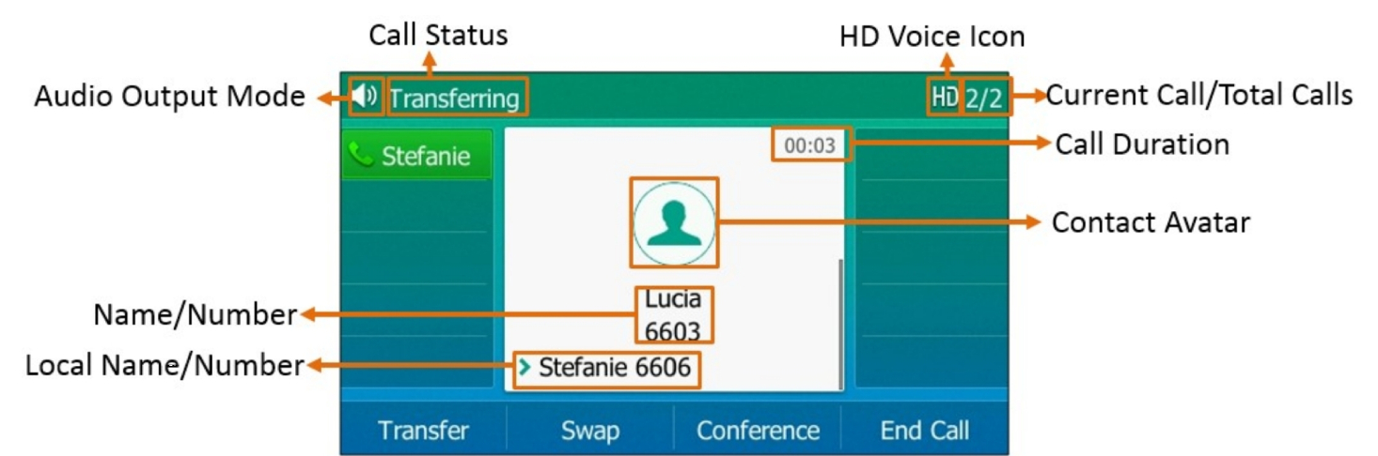
The most basic function of any phone is making and receiving calls. The phone can do those functions in 3 different modes.
- Answering Calls
All the calls whether incoming or outgoing will show as a text box on the LCD screen with contact information. When answering a call, you can do one of the following:
- Pick up the receiver to use it. (Mode 1)
- For speakerphone, press the speaker key. (Mode 2)
- If you have a headset (Mode 3) you would like to use, press the headset button. The Yealink T54W will support wired or wireless headsets if they are compatible and set up correctly. If you are not sure if your headset of choice is compatible, ask your System Administrator or a Metronet representative to see a full list.
- If you are already in a specific mode, (Headset, Speaker phone or the default receiver) the phone will automatically use it for every call, unless you change it. If you are on an active call and get a second call, you will get a call waiting tone (which is a low beep) and you will see the “incoming call” screen pop up again on the display. You can swap back and forth between calls or even put them into a 3-way call. You can also decline, transfer, or mute the call.
- (It is important to note, only one call can be active at a time. So, when swapping between calls, remember to put the caller on HOLD before choosing the other line. If you do not, the first call will drop when you pick up the second.)
Placing a Call
On the Yealink T54W, placing a new call can be done from a couple different ways on the phone. You can start by entering the number on the dial pad. The phone will try to autofill the information as you type it if it is a number in your call history or is listed as a contact. If you have speed dials or extensions programmed on to the idle screen’s line keys, you can also press those to call out. You can also redial a call by going into the Call History and choosing the entry you would like to call back. If you are redialing the last entry in the history, press the History button twice. The Directory icon in the Main Menu or the soft key on the Idle screen, will display all of the business group or personal contacts.
Section II: Phone Features
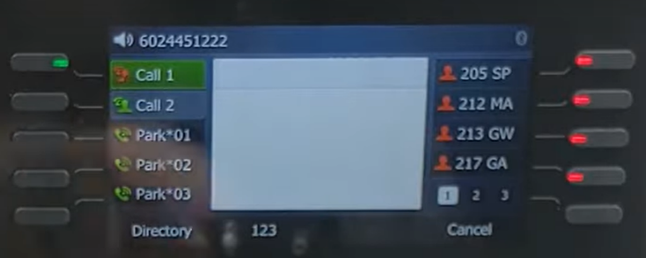
As mentioned in the introduction, the phone has many different functions that can programmed to your specifications. On the T54W, many of the following key types and settings can be managed from the CommPortal either as an individual key or as a mass distribution from an admin user. The keys, settings, and features that are modified by an admin are not overwritable at the end user level.
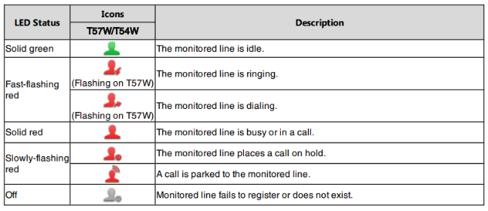
- Enhanced Monitor Extensions- These are extensions that will show you if a person is on an active call or not. If they are, there will be a small, blinking red LED light next to their name. If they are not on a call, the indicator will stay solid. Having a monitored extension is helpful in several different situations, such as being able to see if a person is using their phone, call or transfer to them directly. These extensions are programmable Line Keys which can be configured in the CommPortal. Since these keys use extensions, they can only be used internally.

- Enhanced Call Parking- This feature allows a person to place an active call into an “orbit” or system wide hold, which can then be picked up from any other phone in the business group that has the feature on it. We can program up to three call park orbits per phone in the CommPortal on the Line Keys. If someone is not by their desk, but a call comes in for them, the call can be parked and then picked up wherever that person is that has a phone nearby. So, instead of only having the option of sending it to their phone via their direct extension, which could mean the call will go to voicemail if they cannot get to it in time or forcing that person to go back to their office to pick up the call, the call can go to the system wide hold and be resumed. The Call Parks will be set on the idle screen, and like the monitored extension, the indicator will blink red when the call orbit is in use.

- Group and Directed Pickups- Having Groups, Group Pick-ups and Directed Pick-ups are another convenience feature that helps further direct calls to the appropriate people or departments. There are several different types of groups that can be configured:
- Hunt Groups- Makes a group of phones all ring together on an incoming call.
- Paging Groups- Will set off an audible alarm, followed by an announcement on speakerphone to certain people in the business group.
- Departments- Groups certain phones or users together to allow for them to all be called together or set up so that their group never misses a call, even if the call is going to a different user in the group.
If you have been added to a specific group by your system administrator, a Group Pick-Up will allow you to pick up another phone you hear ringing in your group. To use the feature, when you hear another phone ringing in your group, press the Pick-Up Key, if one has been programmed, or dial *11 to connect a call. If you are not a part of a group, but hear another extension ringing, you could still use a Directed Pick-up to grab the call. To use the feature, when you hear another phone ringing that is not in your group, press the Directed Pick-Up key or dial *12. Then enter the extension to the phone you wish to pick up.

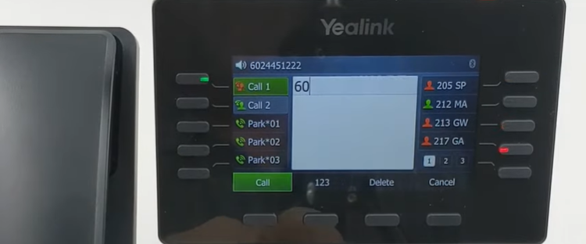
- Call Transfers- Transfers can be done to anyone and do not have to stay within your business group, unless it is to an extension. You have the option to choose between two different types of transfers: Cold/Blind/ Unattended transfers or Warm/Consultative/Attended transfers. Your system is set to use warm transfer by default. You can initiate a cold transfer by pressing the Phone-to-Phone Key (Transfer Key) one time or the Transfer soft key on an active call, and entering the phone number or extension, and then pressing the transfer key again. Blind transfer sends the calling party’s caller id. A warm transfer is done by waiting to press the Transfer key a second time until after the recipient answers which will allow you to announce the call to them. Press the Cancel soft key at any point prior to completing a transfer to return to the original call. You can also program what is called a “One Touch Call Transfer” on your phone’s Line Keys, which allows the user to perform an Unattended (Blind/Cold) Call Transfer to a person without all the extra keystrokes. The key on the phone will be configured to transfer the call to only one number. One way to use this feature would be the user could configure a key on the phone to automatically transfer calls to their mobile phone. If you would like to transfer a call directly to someone’s Voicemail, while on an active call, press one of the Transfer keys and the caller will automatically be placed on hold. Enter 7 followed by the user’s extension. Press the Transfer key again. This completes the transfer to voicemail.

- Speed Dials and Short Codes- Speed Dials can be configured in the CommPortal much like the Call Parks or Monitored Extensions. A speed dial is not required to be a part of your business group to be set up. So, if you want to have your favorite restaurant on speed dial or your best friend’s cell phone number, those can be programmed in the same way. Short Codes are much less common these days, because they can only be configured at the business group level and cannot be changed from the preset configuration. One common group of short codes that Metronet uses are *Star Codes, which will be covered in more detail.

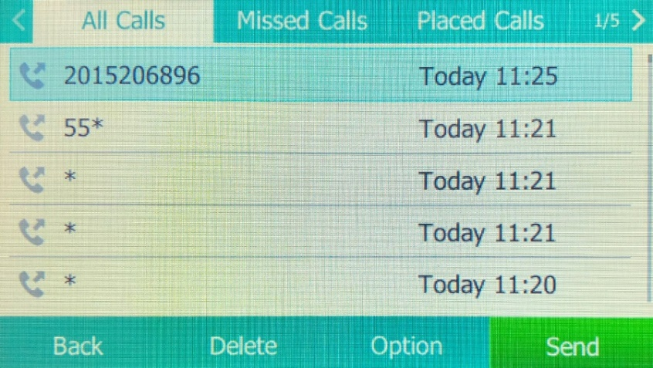
- Call History: All Calls, Received Calls, Dialed Calls, Missed Calls, Placed Calls and Redial- If you need to look your recent call logs, the T54W has a few different call lists to pull recent calls from. If you choose the History Soft Key while on the Idle Screen or the History icon from the Main Menu, it will display your recent calls all grouped together. You can use the Left and Right arrows to move through the different lists to sort them into: Missed, Placed, Received and Forwarded. The Directional Arrow Pad has built in shortcuts so you can quickly access the logs as well. When you are on the Idle Screen, press the arrows for: All Calls (Up) or your Contact Directory (Down). Once you are into the History, you will see different soft keys: Back, Delete, Option, Call. Back will take you out to the Idle Screen. Delete will allow you to delete that single history entry. The Option soft key will give you several additional choices: Detail, Add to Contacts, Add to Blocklist, and Delete All. If you need to see older call logs that might no longer be available to view on the phone anymore, you can access them on the admin CommPortal by selecting Call Logs and then setting the date range you wish to see.

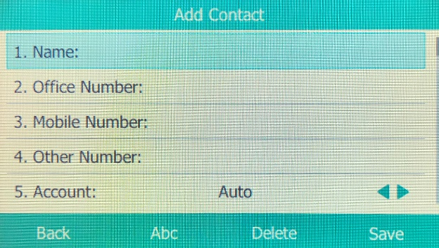
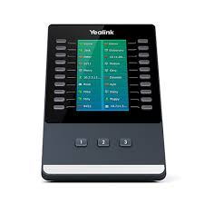
- Contact Directory- To access your Contact Directory, press either the Directory soft key on the Idle Screen or the icon on the Main Menu. If requested, all the contacts from your business group can be preloaded into the phone for you from the CommPortal. Additional contacts and sub-directories such as Favorites or Blocked Numbers can also be created and managed by you. To add a new contact, open the Directory and choose to Add Contact. Enter all the information you want to save for the new contact and then press the Save soft key. If you want to add a contact from the Call History, navigate to the call you want to add and press the Option Soft Key then select Add. Edit any information that you need to update or change, and press Save. Once the contact is in the directory, you will be able to add the number as a Favorite or to the Blocklist if needed. Under the Network Contacts you will also a tab labeled “MLHGS”. This stands for Multi-Line Hunt Groups. Programming these into your phone would be done on the CommPortal and would be uploaded with your business contacts. These entries will allow certain groups of phones to all ring together when called. If your Business Group has more contacts, speed dials, hunt groups or extensions than available spots on the desk phone, we also have a device called a Side Car, which can hold up to an additional 80+ extensions. The T54W can support up to three connected side cars.

- Paging/Intercom- The Paging/Intercom system is, by default, only going to transmit to the phones of other users on site. Paging is a one-way communication preceded by a warning tone and then the announcement, but the receiving party cannot reply. On the CommPortal, you can create Paging Groups, so you can reach to certain departments or people without it going to the entire company. The T54W phones have Paging Group 1 already configured in the system to page the entire company. If your press the Page Soft Key, you will see a list of all the configured groups. Use the arrow pad to scroll and press the Page soft key again. Once you hear the tone, begin speaking. When you are done, end the call. If a page is sent, the receiving party does not have the option to decline it. If they are on an active call, they will receive it once they hang up. Intercom dialing is slightly different from paging. This two-way communication gives off the tone, like a page, but the recipient can reply to the person or group sending it. These announcement systems are used primarily for quick interruptions, questions or to relay time sensitive information. As with paging, intercom dialing within the group will automatically come up on speakerphone. You can change modes to handset or headset after it is received. On the phone, the Intercom function is a shortcut on the Main Menu. Paging is set up as a Soft Key on the idle screen. We also offer loudspeaker systems that can be installed in buildings with their own numbers and extensions, called Algo speakers. These would have their own phone numbers and extensions so specific ones can be reached. If you need to add these, please ask your salesperson about getting them on your account. If you have an existing system already set up, we are normally able to connect them as well.

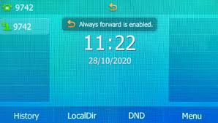
- Call Forwarding- When you are unable to answer the phone, your T54W can be programmed to handle the calls in different ways. By utilizing Call Forwarding, you can send calls directly to alternate numbers. Setup of Call Forwarding can be done by using the *Star Codes, on the home page of the end user CommPortal, the Forward screen icon on the main menu (also in Settings >>> Features) or by reaching out to Metronet. There are two different call-forwarding options; one being unconditional call forwarding which means the desk phone will never ring and the call will immediately transfer to the alternate number. Do Not Disturb is a type of unconditional forwarding. The other type is conditional call forwarding, and like the name suggests, forwards the calls when certain conditions have been met. Voicemail is a type of conditional call forwarding and is obviously the default for most phones, but other conditions such as: Busy or No Answer are also available. You can view and change these options on the user CommPortal home screen. Call forwarding can also be disabled altogether and after the phone stops ringing, the line would just drop. *Star Codes can also be used for call forwarding functions and can set this up or disable them. Once call forwarding has been set up, it will always use the last saved number as the default, unless changed by the user.

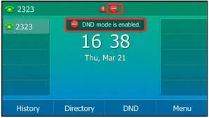
- DND (Do Not Disturb) - Do Not Disturb is like the cell phone feature “Airplane Mode”, but for the desk phone. This Unconditional Call Forwarding will set your to not ever ring and will automatically go to the number you have designated to send it to, again most commonly, your voicemail. You can use the DND soft key shortcut on the Idle screen to quickly turn it on or off. You can also use the Left and Right arrows on the Idle Screen to use the feature. When it is enabled, you will see a red circle with a white line in it on the shortcut, next to your line appearances and in the status bar. You will still receive voicemail notifications while in this mode.

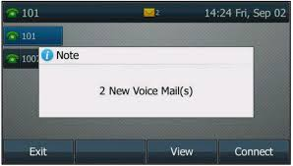
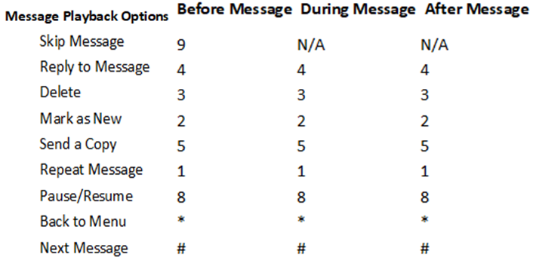
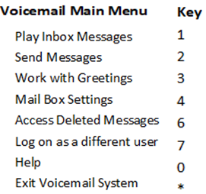
- Message (Voicemail) - The Voicemail icon is listed as Messages on the Main Menu and there is also an integrated Voicemail key to the right of the number pad. If the Voicemail on the T54W seems vaguely familiar to you, it likely because it is like what most cell phone providers use with their Visual Voicemail systems. When you open the voicemail, you do not have to listen to each message in order and press keys to manage them anymore. The voicemails will show up as a list on your screen that you can navigate through using the arrows. When a message is selected, there are options to see details, play/pause it, forward it, delete it, redial the caller and even add the person to your contacts. For you to use the system you will need to configure your profile with your greeting and pin code options, if you want them. Press one of the Message keys on the phone to start the process. When setting your PIN (if you want one), choose a unique six-digit PIN to authorize your mailbox and follow the prompts. For even more customization options, log on to the Metronet CommPortal. From the Message settings, you can set or opt of the PIN, get emailed notifications of new messages (Premium users can even receive transcripts of voicemails emailed to them) and multiple personalized greetings. You have several greeting options to choose from like a default system message, your name or number with the default message, or your own customized recording. Sometimes businesses may want to have a “general voicemail” that picks up the main line for the company. Users in the business group can have this general voicemail programmed into the Line Keys. Whenever there is a new message waiting in the inbox, you will see a red, flashing light on the upper right-hand side of the phone and an envelope will appear on the status bar and a number will be on top of the messages icon on the LCD showing new messages. It is important to remember, if you do have two mailboxes, they both need to be checked to clear the “message waiting” icons. The email notifications can be sent to you on multiple emails. The Transcription service is not available for General Voicemails. You will also see option in the phone to “Call Voicemail”, which just dials into the system and would require you to follow the voice prompts. This is the same process as using the *Star Codes *98 (*318 for MN West) and listening to the messages. The voicemail can also be checked from an outside line, like a cell phone. Call the number of the desk phone and let it ring to voicemail and press the star key (*) and enter your six-digit pin to identify your mailbox. To manage the voicemail when you call in to the system, you will need to follow the prompts and use the keypad to do specific functions.

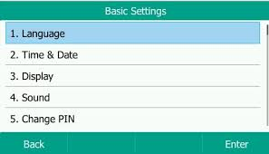
- Settings- If you need to change anything on the phone such as the language, volume, ringtones, background displays, date/time format, time zone, screen brightness and screen time out, those changes MUST be done on the CommPortal Key Manager site under Preferences. There is a Basic Settings Main Menu option, however, changes made there are not permeant and will be returned to default whenever the phone is rebooted. There is also an Advanced settings option, but this requires an Admin PIN to access it. Metronet does NOT have that PIN information, as it is a Yealink setting. If you need to see detailed network, software or hardware information for the T54W, press either the Status icon on the Main Menu or the OK (Center/Select key) while on the Idle screen and it will show you information on the equipment and how it connects to the network.

- Section III: Additional HPBX Phone Features
HPBX phone systems do have some additional features that may be new to you; we will discuss a few of them in this section.
- Star Codes- Another call feature the Yealink phones can support are “*Star Codes”. Since most of these functions like Call Forwarding, Call Parking, and Paging that have *Star Codes are already pre-programmed into the phone as shortcuts or soft keys. There is not as much of a need for them on the desk phones. However, since Metronet also offers wireless HPBX systems, these codes are still needed since those phones do not have the same key options. *Star Codes also known as “short codes”, offer a way for you to quickly hit a couple of keys and have your phone perform different functions, such as pressing *98 (*318 for MN West users) to directly dial to your personal voicemail as opposed to dialing the full mailbox number.

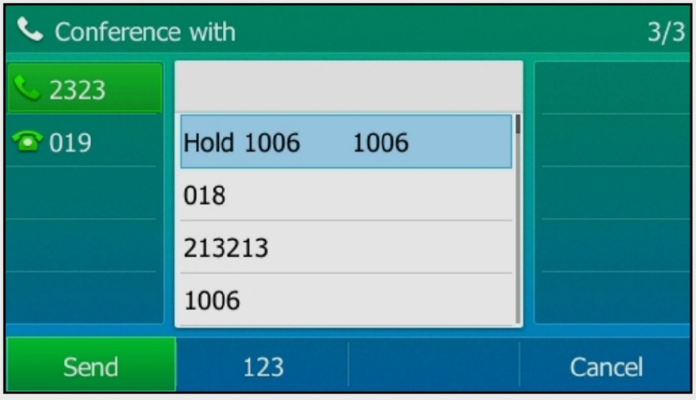
- Multi-Party Conference Calling/3-Way Calling- Conference Calling or 3-Way calling is another feature available on the T54W phones. To start a 3-way call from the phone the person originating the call must add each user individually. You would initiate a call with one person and then put them on hold and then call your second user and press Conference to join the calls. By default, the maximum number of lines that can participate is 10 (including you), but it can be increased if requested. If your business needs to be able to conference with larger parties, it might be time to consider adding a feature called a “Conference Bridge”. The feature includes a phone number and 2 PIN numbers. One PIN is used by the call administrator to set up the virtual conference room. The other is a participant PIN, used by everyone else to join the call. Each bridge also includes a set number of “spaces” for the participants and a monthly allowance of free minutes to use when people to login to the call. To initiate the conference call, you do it in a few different ways:
- On an Active Call / Dialing the Other Parties
-Tap the Conference soft key and the caller will be placed on Hold.
-Press the Add Call soft key and dial the number you want to conference in and press Conference.
-When the second party answers, press the Conference key again and now the participants are on the call together, indicated by a new icon showing 3 people.
- Merge Two Calls into a Conference
-Place two calls on the phone.
-Select the desired call for a conference and ensure that the call is active.
-Select Conference.
-Highlight the desired held call and select Send.
-The active call and the selected hold call are joined into a conference.
- Create a Conference While Transferring a Call
-Select Conference after talking with the contact you want to transfer a call to.
-The target contact and the caller are joined into a conference with you.
- Other Conference Call actions that the administrator on 3-way and conference calls can manage are:
-Hold/Resume- Press the Hold key to hold it, the Resume key to resume it.
-Mute- This will mute the local microphone during a conference call, other participants can hear each but cannot hear you. Press Mute again to unmute.
-Far Mute- The muted party can hear everyone, but no one can hear the muted party.
-Far Hold- The held party cannot hear anyone, and no one can hear the held party.
-Remove- To remove the party from the conference call.
-Split- To speak with one individual once the conference is ending, this will pull an individual call out of the conference call and places them on held calls.
-End- Select End Call key to end the conference call. When you initiate a conference call and disconnect from it first, the other parties will be automatically dropped.

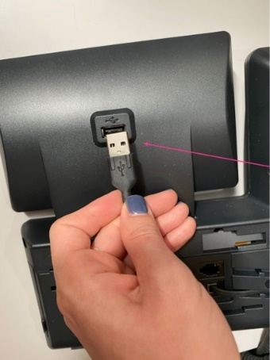
- Record Calls- The Yealink T54W has a USB port on the back of the phone, behind the LCD screen that can be used for external local storage of recorded calls (as well as headsets and side cars). Up to four hours of recordings can be saved in one .wav file. When a USB flash drive is attached to the phone, the USB icon displays in the status bar with a message indicating how much recording time is available. During an Active call, select the More Key, then Record and then Start. An “R” displays on the USB icon to indicate recording is in progress. To end recording, select Stop or Back and then End Call. If you need to set a break in the recording with a pause, Pause, and Resume to resume. To play recordings, navigate to Settings, Features, Removable Storage Media, Browse Recordings. Select a file, Open, and then Play. Recordings can also be deleted from the same screen. Please remember to always give the person being recorded, the chance to decline.

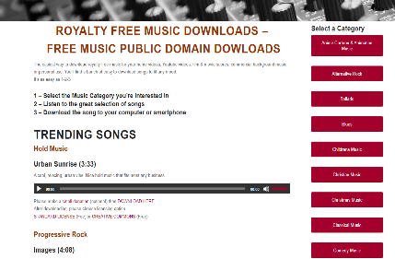
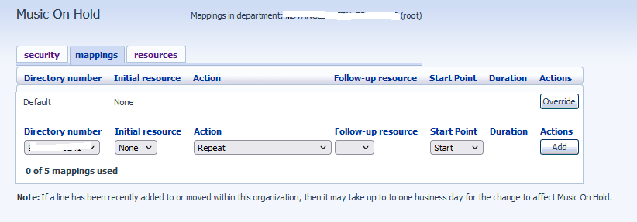
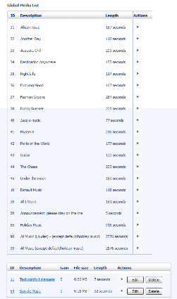
- Music On Hold- Another free feature of the HPBX system allows you to set Music on Hold for your customers to hear instead of just dead air. This free service can be set up with the preset music choices provided to you in the Commportal System on your Admin Portal. However, if you have songs that you have paid to license, are your own compositions or music that is “royalty free” or in the public domain. Since, public domain music is material to which no exclusive intellectual property rights apply, these files are free to download and easy to add to your system. Copyright material that you do not own or have permission to use would need to be changed. You can have a different type of music on hold for each individual line on the account, or one that will apply to the entire business group. Once you go into the portal and select the number, your “initial resource” field will be the song you want to pay when a customer is placed on hold from that number. If you would like to have recorded announcements interrupt the song, that is also an option under the actions, and selecting either the “initial” or “follow-up” interruptions. You can then tell the system if you want to resume the music, either at a random point in the song, or at the beginning, and then hit “Add” to save the selection for that number. If you ever need to modify any of these music or announcement settings, you will see an “Edit” button will appear once it has been saved. There is a limited amount of space available to save the files (usually it is 25MB) and (usually) has a cap of 5 different resources you can use to pull music from.
Section III: CommPortal
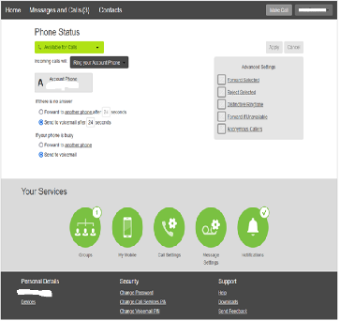
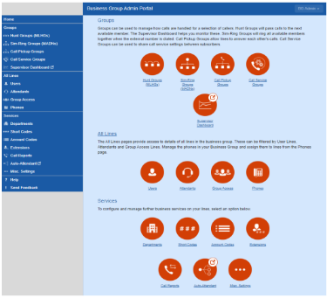
While some of the features we have discussed can be controlled directly from the phone, you and your Network Administrators have even more access via the Customer CommPortal, and many things can only be adjusted there. Through the course of this training session, we have discussed the CommPortal several times. This tool is one of the most powerful phone management features that you, as customers, have access to. As we have discussed, there are two versions of this site: one for End Users and one for Administrators. End Users have limited access but can control their phone’s individual functions like voicemail and password resets, call forwarding and key management on the phones. Administrators accessing the portal have more “group level” functions such as modifying hunt groups, resetting voicemail or CommPortal passwords, changing extension numbers, reassigning physical phones, changing auto attendant settings (with the exception of audio), changing a user’s name and setting up music on hold. The side by side illustrations are of the two different dashboard home screens. To manage all functions of the Time of Day, General Voicemail or Auto Attendant numbers, login to those numbers directly via the End User Portal. After any changes are made in the portals, remember to reboot your phone to see the changes immediately, or wait for the phone to auto update the new configuration settings overnight. You can either unplug the phone from power for 15-30 seconds or choose the Restart Phone option under the Basic Settings on the phone’s Main Menu. Under the picture of the two different user dashboards is the Key Manager home screen. There are a lot of programmable options seen here, so if you have trouble setting things up on your own to look or act exactly how you want, reach out to an administrator or a Metronet representative.

Business Administrator Portal Homepage End User Portal Homepage
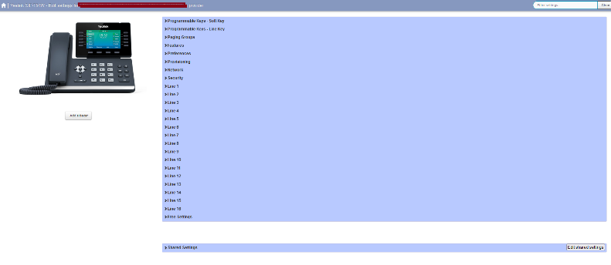

Metronet Key Manager

HPBX phone systems may look complicated at first, but once you start to work with the phones a bit more, hopefully it will all become very easy to remember. I hope you enjoy the phones and found this presentation helpful. I am adding my contact info at the bottom if you have additional questions. Thank You!!
Project Management/HPBX Trainer Info: Matt Hotz matt.hotz@metronet.com 812.316.0826
For additional support and resources, please visit us at: http://metronetinc.com/hpbx or https://business.metronetinc.com/business-voice/metronet-business-phone-technologies/
For live tech support, please contact the MetroNet Business Tech Support Center at 833.393.6857 or business-tech-support@metronetinc.com
For questions regarding pricing, promotions, or billing, please contact the MetroNet Business Customer Support Center at 855.769.0936 or business-customer-service@metronet.com

