ALEKS PPL is for use by Augustana students who would like to improve their math placement. It’s for students who have a Math Index Score (MIS) and a math placement but may be ready for a higher-level MATH course. Access to ALEKS will cost you about $15, payable with a credit/debit card when you establish your account. Follow the steps below to get started.
Important: You can take assessments (four maximum) within the program to check your progress. You’ll receive confirmation of your placement immediately. But your score is not official until you take a timed, proctored assessment on campus. To avoid a discrepancy between your own assessment and the proctored one, do not get help from any person or resource while taking your assessments.
Step 1: Visit www.aleks.com and select SIGN UP NOW!
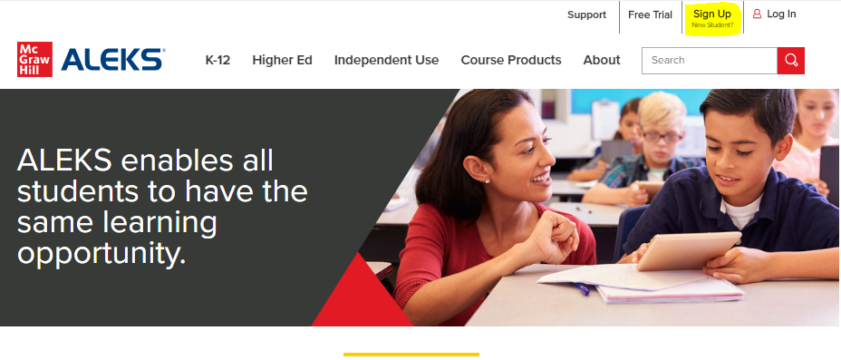

Step 2: Enter the 10-character ALEKS code UJAMU-PUKXW into the Class Code box. Then select Continue. This course code is only for use by students who have a Math Index Score but want to improve their math placement.
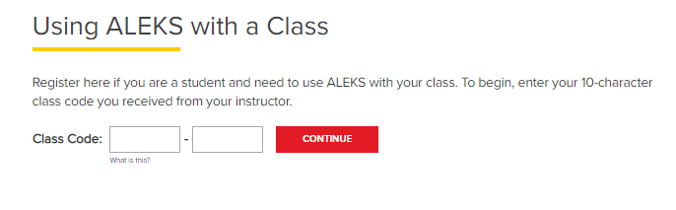

Step 3: Verify Your Class is 2021-2022 E-commerce, Fall 2021. If the information is incorrect, select (Cancel) to re-enter the ALEKS Class Code. If the information is correct, select Confirm.
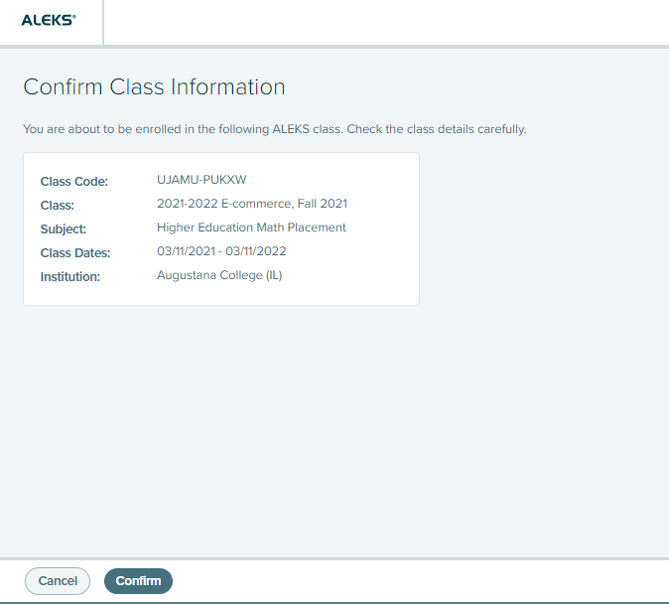

Step 4: Select “No, I have never used ALEKS before.” Then select Continue.
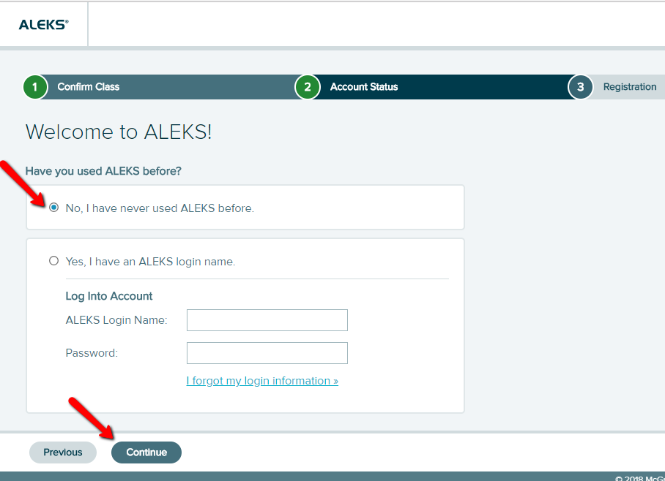

Step 5: Complete the Student Information and be sure to write down the password you create. Agree to the Terms of Use and then select Continue.
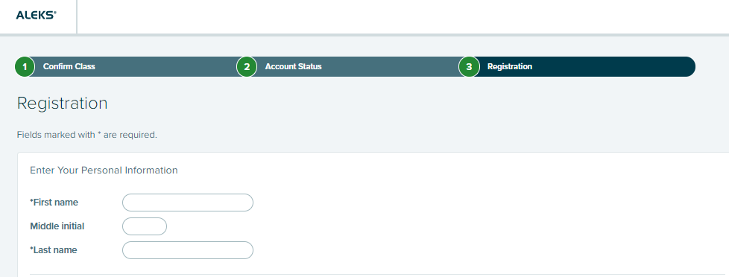

Step 5, continued

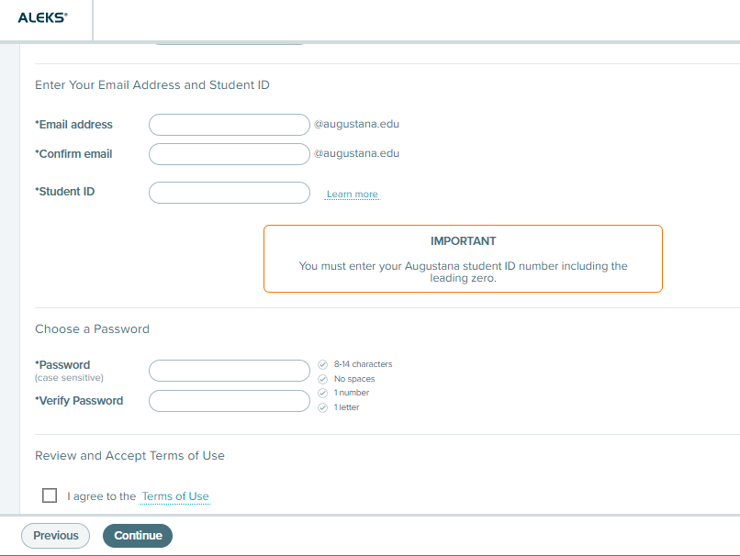

Step 6: You’ll next see your Login Name generated by ALEKS. A confirmation email will be sent to the email address you provided that includes your Login Name. Be sure to save this information.

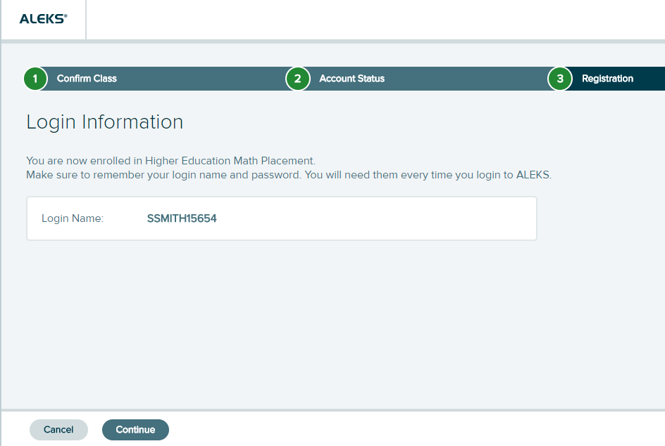

Step 7: You need to purchase an access code next. Click the top box.
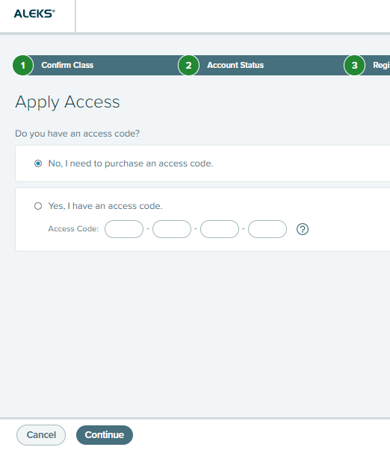

Step 8: Register for your access code by completing the boxes.
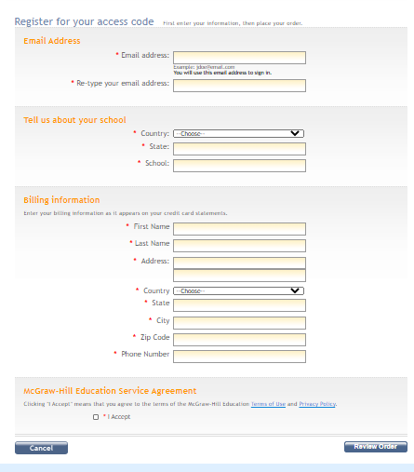

Step 9: Review your order and click on “Payment.”
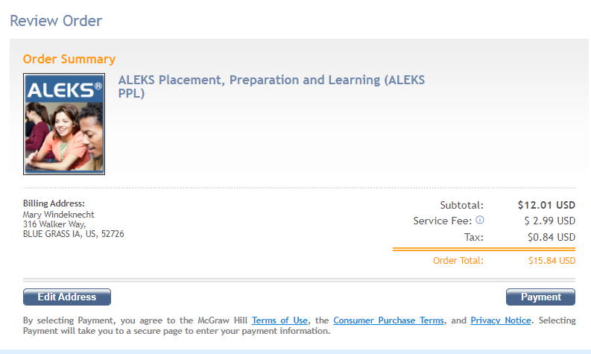

Step 10: Enter your credit/debit card information and place your order. 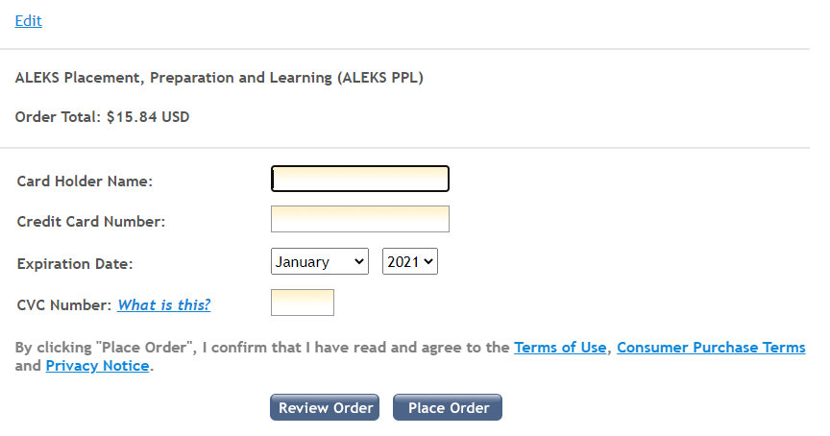

Step 11: Look for the confirmation email and click on “Complete Registration.” Follow the instruction.
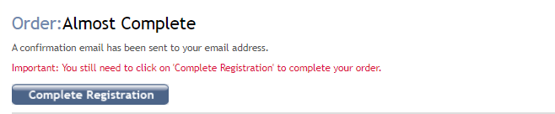

Step 12: On the next screen select Continue.
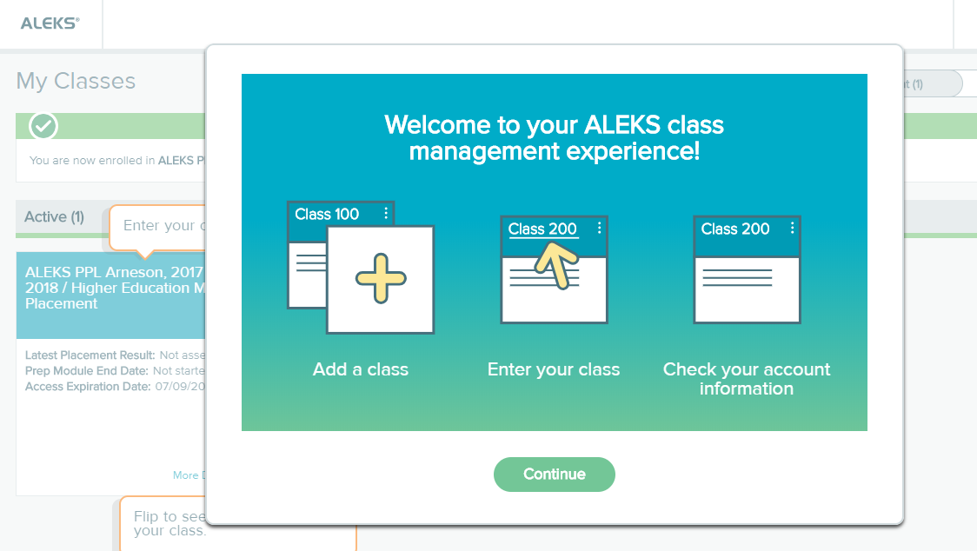

Step 13: Click on the title 2020-2021 E-commerce, Fall 2021 to enter your ALEKS PPL account. Follow the instructions.
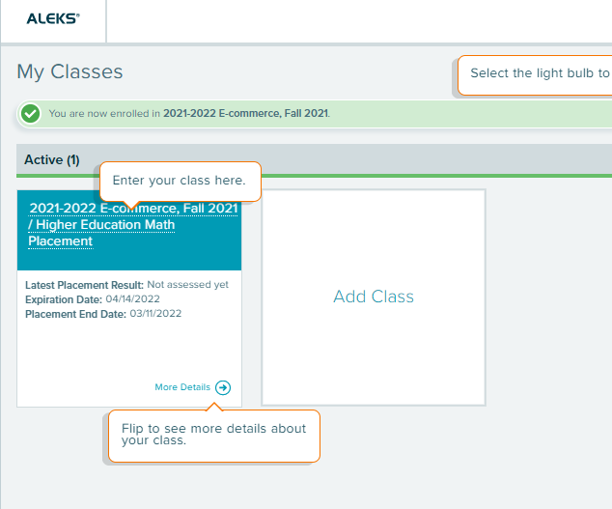

Important:
You’ll need your Login Name and Password each time you log into ALEKS PPL. Visit www.aleks.com and enter your login credential.
Questions or problems? Email advising@augustana.edu.

