Heat / Cold Injuries

General Duty Clause, Section 5(a)(1), 29 USC 654, to keep your workplace free from recognized serious hazards, including ergonomic hazards.

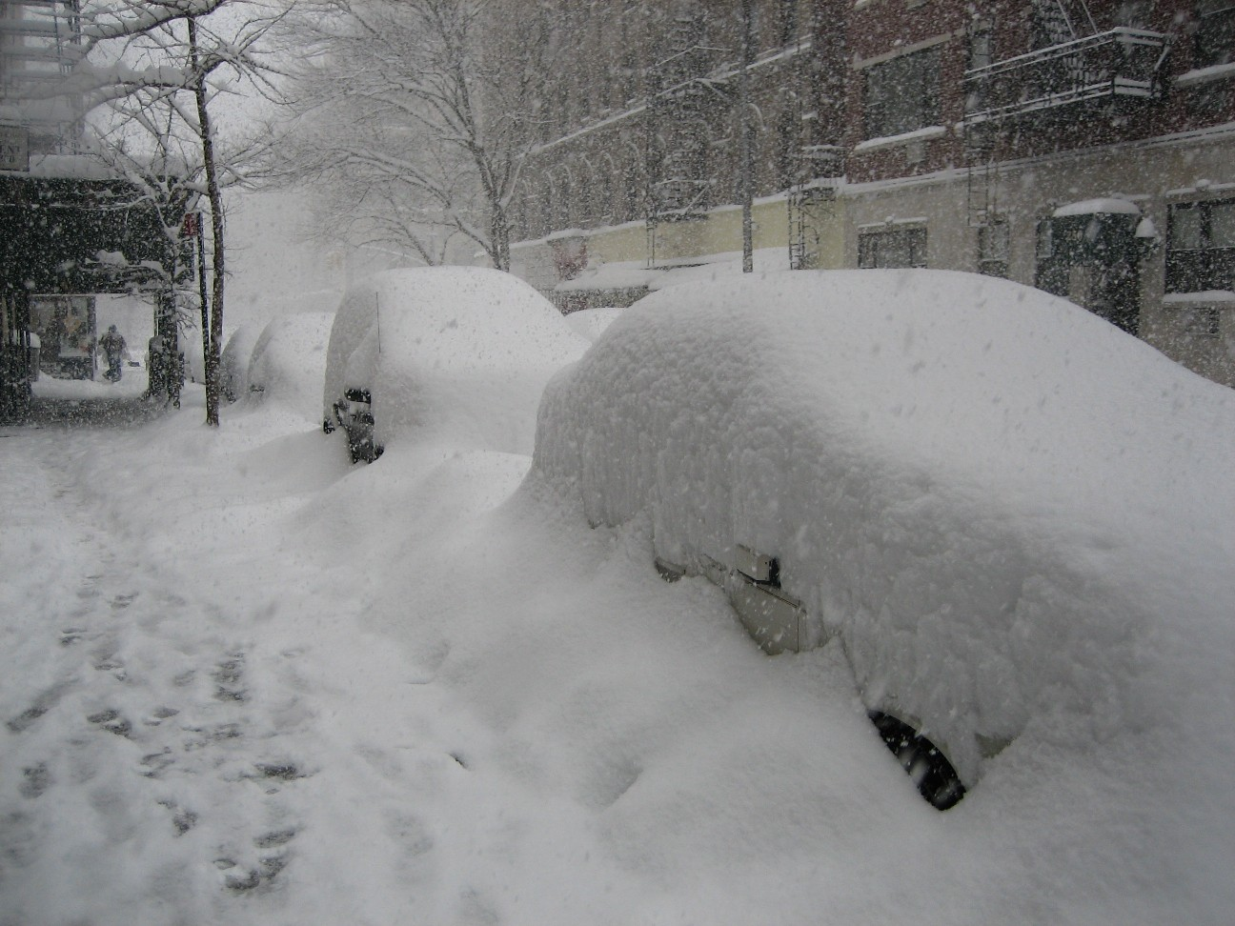

Contents
I. Introduction...................................................................................................................3
II. Purpose ......................................................................................................................3
Ill. Responsibilities …....................................................................................................3-4
IV. Policy ......................................................................................................................4-6
V. Definitions ……............................................................................................................6
VI... Reference …….........................................................................................................6

I. Introduction

Augustana College employees are exposed to extremes in temperature, over the course of a year. A preliminary news release from the Bureau of Labor and Statistics reported that there were 61 fatal occupational injuries as a result of exposure to temperature extremes in 2012 (ref. 1).

II. Purpose

The purpose of the Heat / Cold Injuries Program is to raise Augustana College employees’ level of awareness in identifying the common risk factors, types of illness/injuries, signs/symptoms and treatment of heat and cold injuries. This level of awareness is raised by annual training. Only through active participation by management, supervisors and employees can the awareness level of heat / cold injuries be raised, thereby minimizing heat / cold injuries.

Ill. Responsibilities

- Management
Know the signs and symptoms of heat / cold injuries. Ensure environmental conditions are monitored and be watchful for signs for overexposure. Be aware of the factors that can increase the risk of heat / cold related injuries and know your workers medical history.

- Employees
Know the types of heat / cold related injuries. Know the signs and symptoms of heat / cold injuries and be aware of those signs when working with others. Be aware of the factors that can increase the risk of heat / cold related injuries.

IV. Policy

- Heat

- The three types of heat related injuries are:
- Heat cramps.
- Heat exhaustion.
- Heat stroke.
- Human factors that increase the risk of heat related injuries.
- Poor nutrition.
- Poor physical condition.
- High / Low % body fat.
- Lack of acclimatization.
- Over 40yrs old.
- Previous heat illness.
- Pregnancy.
- Diet plans.
- Higher air temperature, more direct sunlight, higher radiant heat, higher humidity and lower air movement are some of the environmental factors that increase the risk of heat related injuries.
- Job factors that can increase the risk of heat related injuries.
- Work intensity.
- Work duration.
- Work location.
- Clothing (i.e. heavier and more impermeable clothing increase the risk).
- Respiratory protection.

- Cold

- The four types of cold related injuries are:
- Frostnip.
- Frostbite.
- Hypothermia.
- Trench Foot.
- Major causes for cold related injuries.
- A temperature of 41deg. F with other contributing factors.
- Improper clothing and equipment.
- Sweating or in contact with water.
- Contributing factors for cold related injuries.
- Fatigue.
- Dehydration.
- Alcohol intake.
- Body’s response mechanisms
- Blood vessel constriction (called vasoconstriction) to reduce heat loss and make the skin a better insulator.
- When vasoconstriction fails the body uses shivering in an attempt to increase temperature.
- Behavior is the key to prevent cold related injuries. Put on warmer clothing and increase activity.
- Workers should be sure to drink fluids lost during activity, change out of wet clothing as soon as practical, and use the buddy system.
- During inclement weather supervisors should adjust employee work/rest schedules accordingly and allow for a warm work period if needed.

V. Definitions
Frostnip- is the mildest form of a freezing cold injury. Only the very outer layers of the skin freeze. Frostnip is usually on the cheeks, earlobes, fingers, and toes, but can be found on the nose and chin.
Frostbite- Frostbite occurs when the deep layers of the skin and other body tissues freeze (tissue temperature <28°F-30°F). Ice crystals form, destroying tissues and causing permanent damage. In severe cases, amputation of the frostbitten area may be required. Frostbite usually affects the cheeks, chin, ears, fingers/hands, and toes/feet.
Heat Cramps- painful muscle spasms that result from the loss of salt and electrolytes due to excessive sweating
Heat Exhaustion- is a state brought on by the loss of fluids and electrolytes lost during excessive sweating.
Heat Stroke- results when the body's core temperature gets too high and the body is no longer able to cool itself. Heat stroke is a severe medical emergency which could result in death.

VI. Reference

- National Census of Federal Occupational Injuries in 2011 (Preliminary Results) News Release, Bureau of Labor Statics, US Department of Labor, USDL-12-1888, Sept. 20, 2012.

